
Pak-Austria Fachhochschule:
Institute of Applied Sciences and Technology (PAF-IAST)
LAB REPORT
Lab 03: Data Wrangling with NumPy and Pandas
(Housing Dataset Exercises)

Course: Machine Learning Lab
Department: Artificial Intelligence
Semester: 5
Submitted By: Hassan Mahmood
Registration No.: B24F0089CE001
Lab Instructor: Mr Rafiullah
Submission Date: 28 October 2026

Task 1
NumPy practice: Create a 5×4 array of random integers between 10 and 99 (seed 0). Find the maximum of each column and the row with the largest sum; replace all values below 30 with 0 using a mask; and compute the column-wise z-scores without using loops.
Code
"""
Lab 3 Task 1 — NumPy practice:
Create a 5x4 array of random integers 10–99 (seed 0).
Find column maxima and the row with the largest sum;
replace values below 30 with 0 using a mask;
compute column-wise z-scores without loops.
"""

import numpy as np

def main() -> None:
np.random.seed(0)
arr = np.random.randint(10, 100, size=(5, 4))
print("5x4 array (seed=0, ints 10–99):")
print(arr)
print(f"Shape: {arr.shape}\n")

col_max = arr.max(axis=0)
print("Maximum of each column:", col_max)

row_sums = arr.sum(axis=1)
best_row = int(np.argmax(row_sums))
print("Row sums:", row_sums)
print(f"Row with largest sum: index {best_row} -> {arr[best_row]} (sum={row_sums[best_row]})\n")

masked = arr.copy()
masked[masked < 30] = 0
print("After replacing values < 30 with 0:")
print(masked)
print()

# Column-wise z-scores: (x - mean) / std, no Python loops
means = arr.mean(axis=0)
stds = arr.std(axis=0, ddof=0)
z = (arr - means) / stds
print("Column means:", means.round(3))
print("Column stds: ", stds.round(3))
print("Column-wise z-scores:")
print(np.round(z, 3))

if __name__ == "__main__":
main()

Output
5x4 array (seed=0, ints 10–99):
[[54 57 74 77]
[77 19 93 31]
[46 97 80 98]
[98 22 68 75]
[49 97 56 98]]
Shape: (5, 4)

Maximum of each column: [98 97 93 98]
Row sums: [262 220 321 263 300]
Row with largest sum: index 2 -> [46 97 80 98] (sum=321)

After replacing values < 30 with 0:
[[54 57 74 77]
[77 0 93 31]
[46 97 80 98]
[98 0 68 75]
[49 97 56 98]]

Column means: [64.8 58.4 74.2 75.8]
Column stds: [19.853 34.232 12.303 24.474]
Column-wise z-scores:
[[-0.544 -0.041 -0.016 0.049]
[ 0.615 -1.151 1.528 -1.831]
[-0.947 1.128 0.471 0.907]
[ 1.672 -1.063 -0.504 -0.033]
[-0.796 1.128 -1.479 0.907]]

Task 2
Reshaping: Create np.arange(24), reshape it to (2, 3, 4), and take the sum along each axis. State the shape of each result.
Code
"""
Lab 3 Task 2 — Reshaping:
Create np.arange(24), reshape to (2, 3, 4), sum along each axis,
and state the shape of each result.
"""

import numpy as np

def main() -> None:
a = np.arange(24)
print("Original arange(24):")
print(a)
print(f"Shape: {a.shape}\n")

b = a.reshape(2, 3, 4)
print("Reshaped to (2, 3, 4):")
print(b)
print(f"Shape: {b.shape}\n")

for axis in (0, 1, 2):
s = b.sum(axis=axis)
print(f"Sum along axis={axis}:")
print(s)
print(f" Result shape: {s.shape}\n")

print("Explanation:")
print(" axis=0 collapses the first dim -> shape (3, 4)")
print(" axis=1 collapses the middle dim -> shape (2, 4)")
print(" axis=2 collapses the last dim -> shape (2, 3)")

if __name__ == "__main__":
main()

Output
Original arange(24):
[ 0 1 2 3 4 5 6 7 8 9 10 11 12 13 14 15 16 17 18 19 20 21 22 23]
Shape: (24,)

Reshaped to (2, 3, 4):
[[[ 0 1 2 3]
[ 4 5 6 7]
[ 8 9 10 11]]

[[12 13 14 15]
[16 17 18 19]
[20 21 22 23]]]
Shape: (2, 3, 4)

Sum along axis=0:
[[12 14 16 18]
[20 22 24 26]
[28 30 32 34]]
Result shape: (3, 4)

Sum along axis=1:
[[12 15 18 21]
[48 51 54 57]]
Result shape: (2, 4)

Sum along axis=2:
[[ 6 22 38]
[54 70 86]]
Result shape: (2, 3)

Explanation:
axis=0 collapses the first dim -> shape (3, 4)
axis=1 collapses the middle dim -> shape (2, 4)
axis=2 collapses the last dim -> shape (2, 3)

Task 3
Missing data: Fill area_sqft with the mean area of each city (groupby + transform) instead of the median. Compare with median fill, including the vertical-stripe effect in a scatter plot.
Code
"""
Lab 3 Task 3 — Missing data:
Fill area_sqft with the mean area of each city (groupby + transform)
instead of a global median. Compare with median fill and show the
vertical-stripe effect in a scatter plot.
"""

from pathlib import Path

import matplotlib.pyplot as plt
import pandas as pd

DATA_DIR = Path(__file__).resolve().parent / "data"
RAW_PATH = DATA_DIR / "housing_raw.csv"
OUT_DIR = Path(__file__).resolve().parent / "outputs"

def main() -> None:
OUT_DIR.mkdir(parents=True, exist_ok=True)
raw = pd.read_csv(RAW_PATH)

print(f"Missing area_sqft in raw: {raw['area_sqft'].isna().sum()}")
missing_mask = raw["area_sqft"].isna()

# (A) Global median fill
median_fill = raw.copy()
global_median = median_fill["area_sqft"].median()
median_fill["area_sqft"] = median_fill["area_sqft"].fillna(global_median)
print(f"Global median area: {global_median:.2f}")

# (B) City-wise mean fill via groupby + transform
city_mean_fill = raw.copy()
city_means = city_mean_fill.groupby("city")["area_sqft"].transform("mean")
city_mean_fill["area_sqft"] = city_mean_fill["area_sqft"].fillna(city_means)
print("\nCity mean areas used for fill:")
print(raw.groupby("city")["area_sqft"].mean().round(2))

print("\nSample of originally-missing rows after each fill:")
compare = pd.DataFrame(
{
"city": raw.loc[missing_mask, "city"].values,
"median_fill": median_fill.loc[missing_mask, "area_sqft"].values,
"city_mean_fill": city_mean_fill.loc[missing_mask, "area_sqft"].values,
}
)
print(compare.head(10).to_string(index=False))

# Scatter: price vs area — median fill creates a vertical stripe at one x
fig, axes = plt.subplots(1, 2, figsize=(12, 5), sharey=True)

axes[0].scatter(
median_fill.loc[~missing_mask, "area_sqft"],
median_fill.loc[~missing_mask, "price"],
alpha=0.45,
s=18,
label="observed",
)
axes[0].scatter(
median_fill.loc[missing_mask, "area_sqft"],
median_fill.loc[missing_mask, "price"],
alpha=0.9,
s=40,
c="crimson",
label="median-filled",
edgecolors="k",
linewidths=0.3,
)
axes[0].set_title("Median fill (vertical stripe)")
axes[0].set_xlabel("area_sqft")
axes[0].set_ylabel("price")
axes[0].legend()

axes[1].scatter(
city_mean_fill.loc[~missing_mask, "area_sqft"],
city_mean_fill.loc[~missing_mask, "price"],
alpha=0.45,
s=18,
label="observed",
)
axes[1].scatter(
city_mean_fill.loc[missing_mask, "area_sqft"],
city_mean_fill.loc[missing_mask, "price"],
alpha=0.9,
s=40,
c="darkorange",
label="city-mean-filled",
edgecolors="k",
linewidths=0.3,
)
axes[1].set_title("City-mean fill (groupby + transform)")
axes[1].set_xlabel("area_sqft")
axes[1].legend()

fig.suptitle("Missing area_sqft: median vs city-mean imputation")
fig.tight_layout()
out = OUT_DIR / "task3_missing_area_scatter.png"
fig.savefig(out, dpi=150)
plt.close(fig)
print(f"\nSaved plot: {out}")
print(
"Comment: median fill stacks all imputed points on one x-value "
"(vertical stripe). City-mean fill spreads them by city, which is "
"usually more realistic."
)

if __name__ == "__main__":
main()

Output
Missing area_sqft in raw: 32
Global median area: 2682.00

City mean areas used for fill:
city
Islamabad 2854.02
Karachi 2684.17
Lahore 2525.25
Peshawar 2541.73
Rawalpindi 2674.67
Name: area_sqft, dtype: float64

Sample of originally-missing rows after each fill:
city median_fill city_mean_fill
Karachi 2682.0 2684.165138
Islamabad 2682.0 2854.015385
Rawalpindi 2682.0 2674.672414
Rawalpindi 2682.0 2674.672414
Rawalpindi 2682.0 2674.672414
Karachi 2682.0 2684.165138
Islamabad 2682.0 2854.015385
Karachi 2682.0 2684.165138
Rawalpindi 2682.0 2674.672414
Rawalpindi 2682.0 2674.672414

Saved plot: /Users/Macbook/COMP-240L ML/Lab 3/outputs/task3_missing_area_scatter.png
Comment: median fill stacks all imputed points on one x-value (vertical stripe). City-mean fill spreads them by city, which is usually more realistic.

Visualization Output
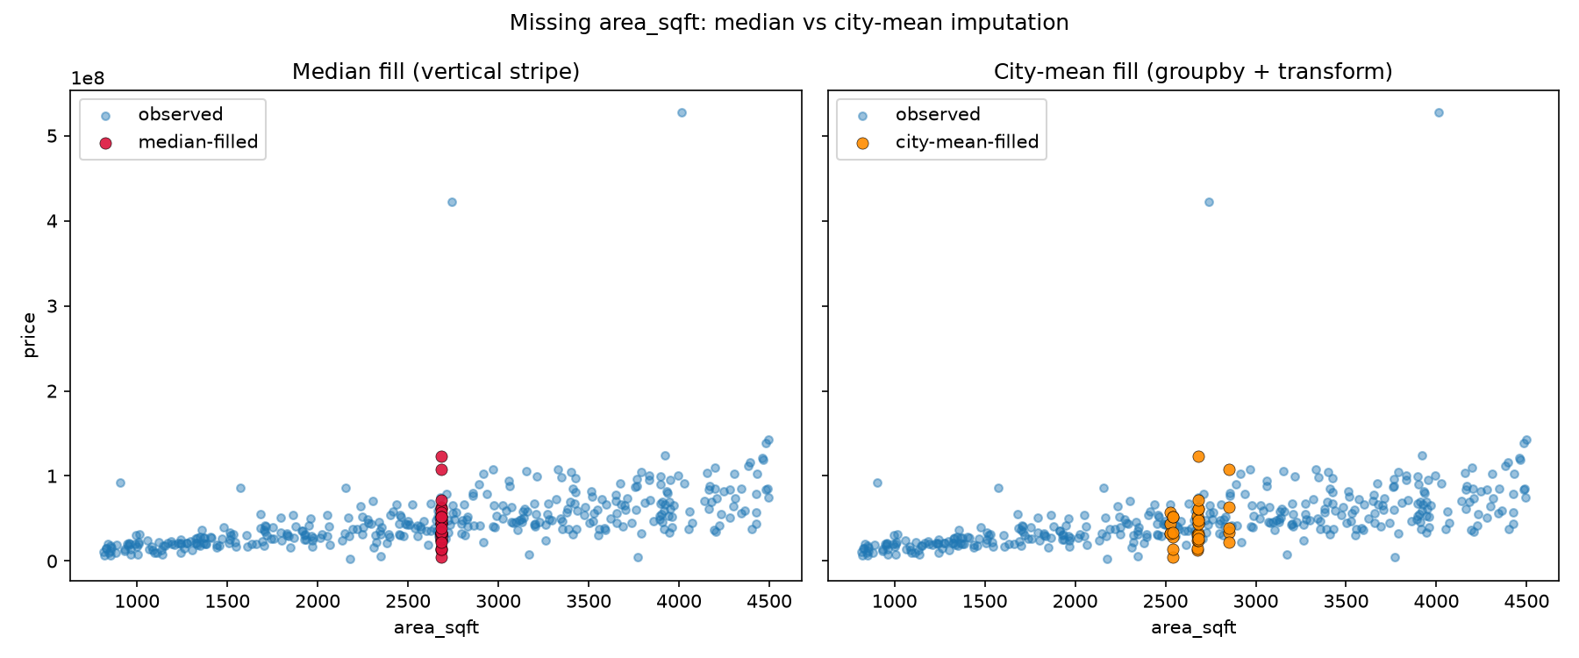

Task 4
Alternative outlier rule: Detect outliers in price_per_sqft using a z-score rule (|z| > 3). Compare the rows found with those flagged by IQR on price.
Code
"""
Lab 3 Task 4 — Alternative outlier rule:
Detect outliers in price_per_sqft using |z| > 3.
Compare with rows flagged by the IQR rule on price.
"""

from pathlib import Path

import numpy as np
import pandas as pd

DATA_DIR = Path(__file__).resolve().parent / "data"
CLEAN_PATH = DATA_DIR / "housing_cleaned.csv"

def iqr_outlier_mask(series: pd.Series) -> pd.Series:
q1 = series.quantile(0.25)
q3 = series.quantile(0.75)
iqr = q3 - q1
lower = q1 - 1.5 * iqr
upper = q3 + 1.5 * iqr
return (series < lower) | (series > upper)

def main() -> None:
df = pd.read_csv(CLEAN_PATH)

# Z-score outliers on price_per_sqft
pps = df["price_per_sqft"]
z = (pps - pps.mean()) / pps.std(ddof=0)
z_mask = z.abs() > 3
z_outliers = df.loc[z_mask].copy()
z_outliers["z_score"] = z[z_mask].round(3)

# IQR outliers on price
iqr_mask = iqr_outlier_mask(df["price"])
iqr_outliers = df.loc[iqr_mask].copy()

print("=== Z-score outliers on price_per_sqft (|z| > 3) ===")
print(f"Count: {z_mask.sum()}")
print(
z_outliers[
["city", "area_sqft", "price", "price_per_sqft", "z_score", "condition"]
]
.sort_values("z_score", key=np.abs, ascending=False)
.head(15)
.to_string(index=True)
)

print("\n=== IQR outliers on price (1.5 × IQR) ===")
print(f"Count: {iqr_mask.sum()}")
print(
iqr_outliers[["city", "area_sqft", "price", "price_per_sqft", "condition"]]
.sort_values("price", ascending=False)
.head(15)
.to_string(index=True)
)

both = z_mask & iqr_mask
only_z = z_mask & ~iqr_mask
only_iqr = iqr_mask & ~z_mask
print("\n=== Comparison ===")
print(f"Flagged by both rules: {both.sum()}")
print(f"Only z-score (pps): {only_z.sum()}")
print(f"Only IQR (price): {only_iqr.sum()}")
print(
"\nComment: z-score on price_per_sqft finds extreme unit prices; "
"IQR on total price finds extremely expensive/cheap listings overall. "
"They overlap partly but are not identical."
)

if __name__ == "__main__":
main()

Output
=== Z-score outliers on price_per_sqft (|z| > 3) ===
Count: 4
city area_sqft price price_per_sqft z_score condition
273 Islamabad 2742.0 421779938.0 153822.01 11.406 Excellent
222 Islamabad 4013.0 527487374.0 131444.65 9.523 Excellent
29 Islamabad 907.0 92625378.0 102122.80 7.055 Fair
271 Karachi 1573.0 85600827.0 54418.83 3.040 Good

=== IQR outliers on price (1.5 × IQR) ===
Count: 9
city area_sqft price price_per_sqft condition
222 Islamabad 4013.0 527487374.0 131444.65 Excellent
273 Islamabad 2742.0 421779938.0 153822.01 Excellent
19 Islamabad 4496.0 143067390.0 31821.04 Fair
255 Islamabad 4483.0 139020820.0 31010.67 Good
325 Islamabad 3921.0 124407582.0 31728.53 Good
198 Karachi 2682.0 123371790.0 45999.92 Excellent
281 Karachi 4459.0 120790882.0 27089.23 Excellent
287 Lahore 4464.0 119314740.0 26728.21 Excellent
158 Islamabad 4394.0 116052224.0 26411.52 Good

=== Comparison ===
Flagged by both rules: 2
Only z-score (pps): 2
Only IQR (price): 7

Comment: z-score on price_per_sqft finds extreme unit prices; IQR on total price finds extremely expensive/cheap listings overall. They overlap partly but are not identical.

Task 5
Filtering: Using loc/query, find (a) Karachi houses older than 30 years with Poor condition, (b) the five most expensive houses sold in 2024, and (c) the share of Excellent houses in each city.
Code
"""
Lab 3 Task 5 — Filtering questions:
(a) Karachi houses older than 30 years with Poor condition
(b) five most expensive houses sold in 2024
(c) share of Excellent houses in each city
"""

from pathlib import Path

import pandas as pd

DATA_DIR = Path(__file__).resolve().parent / "data"
CLEAN_PATH = DATA_DIR / "housing_cleaned.csv"

def main() -> None:
df = pd.read_csv(CLEAN_PATH, parse_dates=["sale_date"])

# (a)
a = df.loc[
(df["city"] == "Karachi")
& (df["age_years"] > 30)
& (df["condition"] == "Poor")
]
print("=== (a) Karachi, age > 30, Poor condition ===")
print(f"Count: {len(a)}")
print(
a[["city", "age_years", "condition", "area_sqft", "price", "sale_date"]]
.head(20)
.to_string(index=False)
)

# (b)
sold_2024 = df.loc[df["sale_date"].dt.year == 2024]
top5 = sold_2024.nlargest(5, "price")
print("\n=== (b) Five most expensive houses sold in 2024 ===")
print(
top5[
["city", "price", "area_sqft", "price_per_sqft", "condition", "sale_date"]
].to_string(index=False)
)

# (c)
share = (
df.assign(is_excellent=df["condition"].eq("Excellent"))
.groupby("city")["is_excellent"]
.mean()
.mul(100)
.round(2)
.sort_values(ascending=False)
)
print("\n=== (c) Share of Excellent houses by city (%) ===")
print(share.to_string())

if __name__ == "__main__":
main()

Output
=== (a) Karachi, age > 30, Poor condition ===
Count: 5
city age_years condition area_sqft price sale_date
Karachi 53 Poor 1134.0 12953019.0 2023-09-07
Karachi 52 Poor 2452.0 31008260.0 2022-01-30
Karachi 38 Poor 1610.0 16960040.0 2024-04-04
Karachi 42 Poor 2682.0 26322885.0 2022-03-25
Karachi 38 Poor 3551.0 30374260.0 2023-06-24

=== (b) Five most expensive houses sold in 2024 ===
city price area_sqft price_per_sqft condition sale_date
Karachi 123371790.0 2682.0 45999.92 Excellent 2024-11-26
Islamabad 108012455.0 2969.0 36380.08 Excellent 2024-01-26
Islamabad 107793054.0 2682.0 40191.30 Good 2024-08-06
Islamabad 107244477.0 3332.0 32186.22 Excellent 2024-10-16
Islamabad 105534635.0 3154.0 33460.57 Good 2024-12-27

=== (c) Share of Excellent houses by city (%) ===
city
Rawalpindi 30.16
Lahore 29.09
Karachi 28.10
Islamabad 25.71
Peshawar 16.67

Task 6
Date analysis: Compute the number of sales and the mean price per month of sale. Plot it as a line chart and comment on any trend.
Code
"""
Lab 3 Task 6 — Date analysis:
Number of sales and mean price per month of sale; line chart; comment on trend.
"""

from pathlib import Path

import matplotlib.pyplot as plt
import pandas as pd

DATA_DIR = Path(__file__).resolve().parent / "data"
CLEAN_PATH = DATA_DIR / "housing_cleaned.csv"
OUT_DIR = Path(__file__).resolve().parent / "outputs"

def main() -> None:
OUT_DIR.mkdir(parents=True, exist_ok=True)
df = pd.read_csv(CLEAN_PATH, parse_dates=["sale_date"])
df["sale_month"] = df["sale_date"].dt.to_period("M").dt.to_timestamp()

monthly = (
df.groupby("sale_month")
.agg(n_sales=("price", "size"), mean_price=("price", "mean"))
.sort_index()
)
monthly["mean_price"] = monthly["mean_price"].round(0)

print("=== Sales and mean price per month ===")
print(monthly.to_string())

fig, ax1 = plt.subplots(figsize=(11, 5))
ax1.plot(
monthly.index,
monthly["n_sales"],
marker="o",
color="steelblue",
label="Number of sales",
)
ax1.set_xlabel("Month of sale")
ax1.set_ylabel("Number of sales", color="steelblue")
ax1.tick_params(axis="y", labelcolor="steelblue")

ax2 = ax1.twinx()
ax2.plot(
monthly.index,
monthly["mean_price"],
marker="s",
color="darkorange",
label="Mean price",
)
ax2.set_ylabel("Mean price (PKR)", color="darkorange")
ax2.tick_params(axis="y", labelcolor="darkorange")

lines1, labels1 = ax1.get_legend_handles_labels()
lines2, labels2 = ax2.get_legend_handles_labels()
ax1.legend(lines1 + lines2, labels1 + labels2, loc="upper left")
ax1.set_title("Monthly sales volume and mean price")
fig.autofmt_xdate()
fig.tight_layout()

out = OUT_DIR / "task6_monthly_sales.png"
fig.savefig(out, dpi=150)
plt.close(fig)
print(f"\nSaved plot: {out}")

# Simple trend comment from correlation of month index vs mean price
x = range(len(monthly))
corr = pd.Series(list(x)).corr(monthly["mean_price"].reset_index(drop=True))
print("\n=== Trend comment ===")
if abs(corr) < 0.15:
print(
"No strong long-term trend: mean monthly price wanders without a "
f"clear rise/fall (corr≈{corr:.2f}). Short-run ups and downs are visible."
)
elif corr > 0:
print(
f"Mild upward tendency in mean price over time (corr≈{corr:.2f}), "
"though month-to-month noise remains."
)
else:
print(
f"Mild downward tendency in mean price over time (corr≈{corr:.2f}), "
"with noticeable month-to-month variation."
)

if __name__ == "__main__":
main()

Output
=== Sales and mean price per month ===
n_sales mean_price
sale_month
2022-01-01 10 43360151.0
2022-02-01 11 56378670.0
2022-03-01 13 44616583.0
2022-04-01 15 75545314.0
2022-05-01 13 40484075.0
2022-06-01 9 39266624.0
2022-07-01 10 84155596.0
2022-08-01 17 49267694.0
2022-09-01 6 45184724.0
2022-10-01 7 50092273.0
2022-11-01 8 55520732.0
2022-12-01 10 33357397.0
2023-01-01 12 51444190.0
2023-02-01 16 44023582.0
2023-03-01 13 36552754.0
2023-04-01 12 67923141.0
2023-05-01 14 50254438.0
2023-06-01 10 58454532.0
2023-07-01 13 42011559.0
2023-08-01 10 56182172.0
2023-09-01 18 61765449.0
2023-10-01 9 32454077.0
2023-11-01 8 43244525.0
2023-12-01 8 40341557.0
2024-01-01 9 56654383.0
2024-02-01 5 14059847.0
2024-03-01 7 37353627.0
2024-04-01 10 41683904.0
2024-05-01 13 50603367.0
2024-06-01 8 49720962.0
2024-07-01 13 42836500.0
2024-08-01 11 41081473.0
2024-09-01 9 47103381.0
2024-10-01 18 47174778.0
2024-11-01 15 45534108.0
2024-12-01 10 50540345.0

Saved plot: /Users/Macbook/COMP-240L ML/Lab 3/outputs/task6_monthly_sales.png

=== Trend comment ===
Mild downward tendency in mean price over time (corr≈-0.25), with noticeable month-to-month variation.

Visualization Output
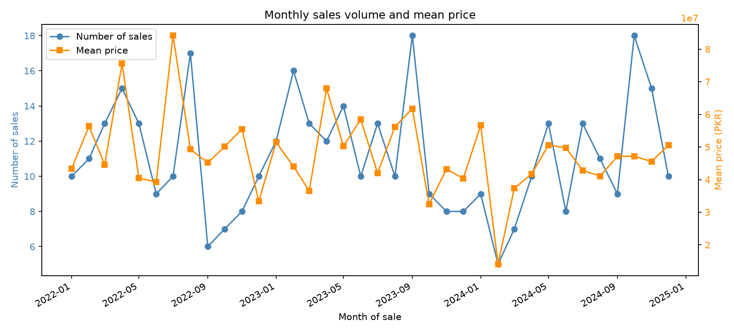

Task 7
Grouping: For each age_group, compute the mean price_per_sqft and the number of houses. Present as a bar chart and comment.
Code
"""
Lab 3 Task 7 — Grouping:
For each age_group, mean price_per_sqft and house count; bar chart + comment.
"""

from pathlib import Path

import matplotlib.pyplot as plt
import pandas as pd

DATA_DIR = Path(__file__).resolve().parent / "data"
CLEAN_PATH = DATA_DIR / "housing_cleaned.csv"
OUT_DIR = Path(__file__).resolve().parent / "outputs"

def main() -> None:
OUT_DIR.mkdir(parents=True, exist_ok=True)
df = pd.read_csv(CLEAN_PATH)

grouped = (
df.groupby("age_group", observed=True)
.agg(
mean_price_per_sqft=("price_per_sqft", "mean"),
n_houses=("price_per_sqft", "size"),
)
.round(2)
)
# Ensure sensible age order
order = ["0-5", "6-15", "16-30", "31+"]
grouped = grouped.reindex([g for g in order if g in grouped.index])

print("=== By age_group ===")
print(grouped.to_string())

fig, axes = plt.subplots(1, 2, figsize=(11, 4.5))

axes[0].bar(grouped.index.astype(str), grouped["mean_price_per_sqft"], color="teal")
axes[0].set_title("Mean price_per_sqft by age_group")
axes[0].set_xlabel("age_group")
axes[0].set_ylabel("Mean price per sqft (PKR)")

axes[1].bar(grouped.index.astype(str), grouped["n_houses"], color="slateblue")
axes[1].set_title("Number of houses by age_group")
axes[1].set_xlabel("age_group")
axes[1].set_ylabel("Count")

fig.tight_layout()
out = OUT_DIR / "task7_age_group_bars.png"
fig.savefig(out, dpi=150)
plt.close(fig)
print(f"\nSaved plot: {out}")

print("\n=== Comment ===")
print(
"Newer homes (younger age_group) tend to show a higher mean price per "
"sqft, while older groups are usually cheaper per unit area. Counts show "
"how many listings fall in each age band."
)

if __name__ == "__main__":
main()

Output
=== By age_group ===
mean_price_per_sqft n_houses
age_group
0-5 21726.72 47
6-15 22668.65 69
16-30 17915.92 116
31+ 15788.50 168

Saved plot: /Users/Macbook/COMP-240L ML/Lab 3/outputs/task7_age_group_bars.png

=== Comment ===
Newer homes (younger age_group) tend to show a higher mean price per sqft, while older groups are usually cheaper per unit area. Counts show how many listings fall in each age band.

Visualization Output
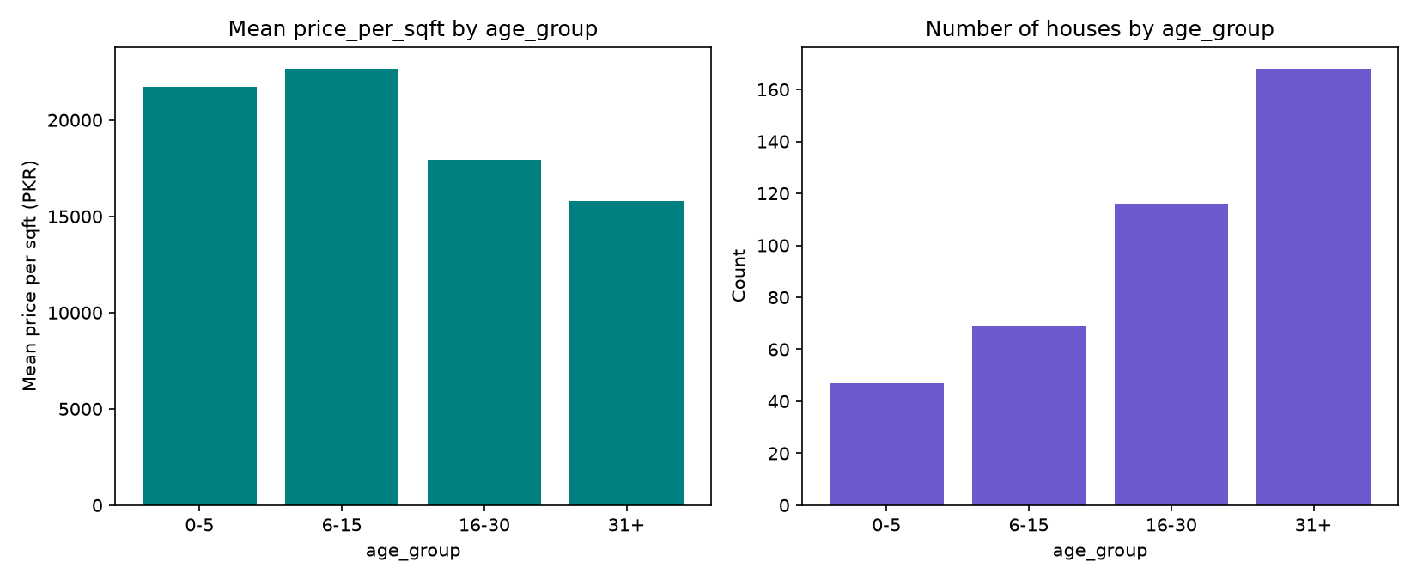

Task 8
Merge: Create a city → average monthly rent table, merge it into the data, and compute a price-to-annual-rent ratio for each city.
Code
"""
Lab 3 Task 8 — Merge:
Create a city → average monthly rent table, merge it, and compute
price-to-annual-rent ratio for each city.
"""

from pathlib import Path

import pandas as pd

DATA_DIR = Path(__file__).resolve().parent / "data"
CLEAN_PATH = DATA_DIR / "housing_cleaned.csv"
RENT_PATH = DATA_DIR / "city_monthly_rent.csv"

def main() -> None:
df = pd.read_csv(CLEAN_PATH)

# Invented but plausible average monthly rents (PKR)
rent = pd.DataFrame(
{
"city": ["Karachi", "Lahore", "Islamabad", "Rawalpindi", "Peshawar"],
"avg_monthly_rent_pkr": [95000, 85000, 140000, 70000, 55000],
}
)
rent.to_csv(RENT_PATH, index=False)
print("=== City average monthly rent (invented, PKR) ===")
print(rent.to_string(index=False))
print(f"Saved: {RENT_PATH}\n")

merged = df.merge(rent, on="city", how="left")
merged["annual_rent_pkr"] = merged["avg_monthly_rent_pkr"] * 12
merged["price_to_annual_rent"] = (
merged["price"] / merged["annual_rent_pkr"]
).round(2)

print("=== Sample of merged rows ===")
print(
merged[
[
"city",
"price",
"avg_monthly_rent_pkr",
"annual_rent_pkr",
"price_to_annual_rent",
]
]
.head(8)
.to_string(index=False)
)

city_summary = (
merged.groupby("city")
.agg(
mean_price=("price", "mean"),
avg_monthly_rent_pkr=("avg_monthly_rent_pkr", "first"),
mean_price_to_annual_rent=("price_to_annual_rent", "mean"),
)
.round(2)
.sort_values("mean_price_to_annual_rent", ascending=False)
)
print("\n=== City-level price-to-annual-rent ratio ===")
print(city_summary.to_string())
print(
"\nInterpretation: ratio ≈ how many years of rent equal the mean sale "
"price in that city (gross, ignoring costs)."
)

if __name__ == "__main__":
main()

Output
=== City average monthly rent (invented, PKR) ===
city avg_monthly_rent_pkr
Karachi 95000
Lahore 85000
Islamabad 140000
Rawalpindi 70000
Peshawar 55000
Saved: /Users/Macbook/COMP-240L ML/Lab 3/data/city_monthly_rent.csv

=== Sample of merged rows ===
city price avg_monthly_rent_pkr annual_rent_pkr price_to_annual_rent
Rawalpindi 9492733.0 70000 840000 11.30
Lahore 35516533.0 85000 1020000 34.82
Rawalpindi 25845214.0 70000 840000 30.77
Islamabad 109595575.0 140000 1680000 65.24
Karachi 55661366.0 95000 1140000 48.83
Peshawar 40475467.0 55000 660000 61.33
Rawalpindi 30860856.0 70000 840000 36.74
Rawalpindi 19212105.0 70000 840000 22.87

=== City-level price-to-annual-rent ratio ===
mean_price avg_monthly_rent_pkr mean_price_to_annual_rent
city
Islamabad 82894042.71 140000 49.34
Peshawar 29713059.61 55000 45.02
Rawalpindi 36676177.21 70000 43.66
Karachi 49468946.23 95000 43.39
Lahore 40196741.61 85000 39.41

Interpretation: ratio ≈ how many years of rent equal the mean sale price in that city (gross, ignoring costs).

